DNS NS Record

🌐 What is a DNS NS Record?
# Source: Chatgpt (GPT-5-Mini) at [1/18/2026]
An NS Record (Name Server Record) specifies the authoritative name servers for a domain. These servers are responsible for answering DNS queries about that domain.
🧠 It tells the internet:
"These are the servers that know the official DNS info for this domain."

🔍 Details of NS Record
# Source: Chatgpt (GPT-5-Mini) at [1/18/2026]
- Purpose: Points a domain (or subdomain) to the DNS servers that hold the authoritative records.
- Format:
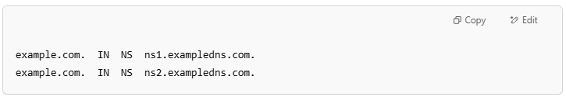
example.com. IN NS ns1.exampledns.com.
example.com. IN NS ns2.exampledns.com.

- Effect: When someone wants to resolve example.com, their DNS resolver asks the NS servers listed here for DNS records.

🌐 Why NS Records Are Important
# Source: Chatgpt (GPT-5-Mini) at [1/18/2026]
- They delegate control of DNS for a domain to specific servers.
- They ensure DNS queries reach the right place for authoritative answers.
- Essential for domain setup and proper internet routing.

Example
# Source: Chatgpt (GPT-5-Mini) at [1/18/2026]

Domain | NS Record (Name Server)
example.com | ns1.exampledns.com
example.com | ns2.exampledns.com

✅ Summary
# Source: Chatgpt (GPT-5-Mini) at [1/18/2026]


Term | Meaning
NS Record | Specifies the authoritative DNS servers for a domain
Purpose | Delegates DNS responsibility to these servers
Needed for | Proper DNS resolution and domain management

